Erk associates with and primes GSK-3β for its inactivation resulting in upregulation of β-catenin
Qingqing Ding, Weiya Xia, Jaw-Ching Liu, Jer-Yen Yang, Jiahong Xia, Dung-Fang Lee, Geoffrey Bartholomeusz, Yan Li, Yong Pan, Zheng Li, Jun Qin and Mien-Chie Hung

¹Department of Molecular and Cellular Oncology, University of Texas M.D. Anderson Cancer Center, Houston, Texas 77030
²Graduate School of Biomedical Sciences, The University of Texas, Houston, Texas 77030
³Department of Surgery, Union Hospital, Tongji Medical College, Huazhong University of Science and Technology, Wuhan 430022, China
⁴Department of Hematology, Oncology and Tumor Immunology, Robert Rossle Cancer Clinic and HELIOS Clinics, Max Delbruck Center for Molecular Medicine, Humboldt University, Charite, Campus Buch, Berlin 13125, Germany
⁵Department of Biochemistry, Baylor College of Medicine, Houston, Texas 77030
⁶China Medical University Hospital, Taichung 404, Taiwan

Abstract
ß-catenin is upregulated in many human cancers, and considered to be an oncogene. Hepatocellular carcinoma (HCC) is one of the most prevalent human malignancies, and individuals who are chronic hepatitis B Virus (HBV) carriers have a greater than 100-fold increased relative risk of developing HCC. Here we report a novel mechanism by which HBV-X protein (HBX) upregulates ß-catenin. Erk, which is activated by HBX, associates with GSK-3ß through a docking motif of GSK-3ß and serves as a scaffold to make a bridge between GSK-3ß and p90RSK, moreover Erk phosphorylates GSK-3ß directly, which primes GSK-3ß for its subsequent phosphorylation at Ser 9 by p90RSK, resulting in inactivation of GSK-3ß and upregulation of ß-catenin to facilitate cell proliferation. The novel pathway is a general signal as it was also observed in cell lines, in which Erk-primed inactivation of GSK-3ß was regulated by receptor tyrosine kinase HER2, growth factor IGF-1 and TGF-ß, and further supported by immunohistochemical staining in different human tumors including cancers of liver, breast, kidney and stomach. In conclusion, the novel mechanism, namely Erk-primed inactivation of GSK-3ß directly links HBX or growth factor/receptor and ß-catenin signal pathway together, and may be involved in the development of multiple human cancers.

Introduction
HBV infection is one of the major causes of HCC in humans. Epidemiological studies showed that 80% of all HCC occurs in HBV-infected individuals. HBV genome is composed of a partially double-stranded circular DNA and contains four overlapping genes: S/preS, C/preC, P, and X. The X gene is the most frequently integrated viral sequence found in HCC, which encodes a 17 kDa protein termed HBX (Arbuthnot and Kew, 2001 P. Arbuthnot and M. Kew, Hepatitis B virus and hepatocellular carcinoma, Int. J. Exp. Pathol. 82 (2001), pp. 77–100. Full Text via CrossRef | View Record in Scopus | Cited By in Scopus (105)Arbuthnot and Kew, 2001 and Cromlish, 1996). HBX is a multifunction protein that can inhibit p53 function and transactivate some transcription factors, including AP-1, NF-κB, CREB, and TBP (Benn et al., 1996, Feitelson et al., 1993, Maguire et al., 1991, Qadri et al., 1995 and Su and Schneider, 1996). Moreover, HBX has been implicated in the activation of many signal transduction pathways, such as the RAS/RAF/MAPK, MEKK1/JNK, JAK/STAT, and PI-3K/AKT pathways (Benn and Schneider, 1994, Benn et al., 1996, Lee and Yun, 1998 and Shih et al., 2000). Malignant transformation has been observed in certain cell lines transfected with HBx gene and in an X gene-transgenic mouse model (Kim et al., 1991 and Terradillos et al., 1997). HBX is therefore considered to play an important role in neoplastic transformation of hepatocytes in HBV-infected liver; however, the molecular mechanism of HBV-induced HCC remains poorly understood.
β-catenin is a key effector of the Wnt signaling pathway. The current model suggests that Axin and adenomatous polyposis coli (APC) gene products serve as scaffolds to facilitate the phosphorylation of β-catenin by GSK-3β (Nelson and Nusse, 2004 and Peifer and Polakis, 2000), and phosphorylated β-catenin is targeted to degradation by the ubiquitin-proteasome system (Aberle et al., 1997 and Kitagawa et al., 1999). Mutations within the binding site of either Axin or APC, or the GSK-3β phosphorylation site of β-catenin, result in the inability of GSK-3β to phosphorylate β-catenin (Morin et al., 1997 and Satoh et al., 2000). Although the molecular mechanism by which Wnt actually regulates GSK-3β is not fully elucidated yet, one finding is that Wnt-activated Dsh causes GSK-3β dissociation from Axin (Li et al., 1999 and Ruel et al., 1999); the other is that Wnt stimulation leads to reduction of kinase activity of GSK-3β (Cook et al., 1996 and Ruel et al., 1999). Thus, the two mechanisms prevent efficient β-catenin phosphorylation by GSK-3β, resulting in stabilization of β-catenin. In addition to the Wnt-dependent stabilization of β-catenin, it has been reported that many growth factors can stabilize β-catenin through phosphorylation of GSK-3β to inactivate GSK-3β (Desbois-Mouthon et al., 2001, Holnthoner et al., 2002 and Playford et al., 2000). Once β-catenin is accumulated in the cytoplasm, it can translocate to the nucleus where it binds to Tcf/Lef and acts as its coactivator to stimulate the transcription of target genes such as c-myc and cyclin D1 (He et al., 1998 and Tetsu and McCormick, 1999) to facilitate cell proliferation. However, the molecular mechanism of growth factors-induced β-catenin stabilization is not completely understood yet.
About 50%–70% of all HCC examined showed an abnormal β-catenin protein accumulation in the cytoplasm and nucleus (de La Coste et al., 1998, Suzuki et al., 2002 and Wong et al., 2001). However, in HCC the β-catenin mutation rate is 13%–26% (de La Coste et al., 1998 and Wong et al., 2001), the Axin mutation rate is 5%–10% (Satoh et al., 2000 and Taniguchi et al., 2002), and no mutation of APC has been reported so far. This led us to speculate that other factors might be involved in the accumulation of β-catenin in HCC. In this study we identify a mechanism to stabilize β-catenin, namely Erk-primed inactivation of GSK-3β, which provides a mechanic link for HBX- and growth factor-induced β-catenin stabilization.

Results
HBX Activates the β-Catenin Pathway
To examine the potential relationship between HBX and β-catenin in HCC, we analyzed the expression of HBX and β-catenin in 53 HCC samples using immunohistochemical staining (IHC) and found that accumulation of β-catenin in both the cytosol and nucleus significantly correlated with the expression of HBX (Figures 1A and 1B). We then tested whether HBX may upregulate β-catenin and its downstream target. Western blot analysis showed higher protein levels of both wild-type β-catenin (de La Coste et al., 1998) and its downstream targets c-myc and cyclin D1 in HBX-stable transfectants, HepG2-X and Hep3B-X, as compared to those of parental cell lines, HepG2 and Hep3B (Figure 1C). In addition, immunofluorescent staining indicated that there was an increase in β-catenin expression and translocation of β-catenin to the nucleus in the HBX-stable transfectant cell lines (Figure 1D); the rates of nuclear β-catenin are 91% versus 53% in HepG2-X and HepG2 cells, and 42% versus 6% in Hep3B-X and Hep3B cells, respectively. Consistently, the transcriptional activity of β-catenin was also increased in HepG2-X and Hep3B-X cells compared to their parental cells when we used a Tcf-regulated reporter to evaluate transcriptional activity of β-catenin (Figure 1E). Moreover, flow cytometry confirmed the more rapid progression in HBX-expressing cells whereby the percentages of cells in S phase and G2/M phase were greater than parental cells. However, both dominant-negative Tcf-4 (DN-Tcf-4) and siRNA-β-catenin blocked HBX-activated transcriptional activity of β-catenin (Figure 1E) and inhibited HBX-induced cell proliferation as indicated by significantly decreased percentage of cells in S phase and G2/M phase (Figure 1F). These results demonstrated that HBX can upregulate β-catenin in both hepatoma cell lines and tumor tissues, and the HBX-activated β-catenin activity is required for the HBX-induced cell proliferation.
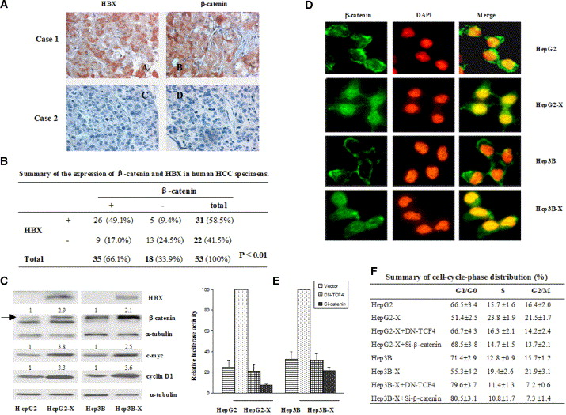
Figure 1.HBX Activates the β-Catenin Pathway
(A) Primary human HCC specimens were stained with antibodies specific to HBX (AA and AC) and β-catenin (AB and AD).
(B) Summary of the expression of β-catenin and HBX in human HCC specimens.
(C) Western blot analysis showed that wt β-catenin and c-myc and cyclin D1, two downstream targets of β-catenin, are abundant in the HBX-expressing HepG2 and Hep3B cells. The arrow marks the position of wt β-catenin, and a known mutant β-catenin (de La Coste et al., 1998) migrating below the wt β-catenin was also detected in HepG2 and HepG2-X cells.
(D) An immunofluorescence assay was performed on different cell lines as indicated to measure the expression and cellular localization of β-catenin (green). The nucleus was stained with DAPI (red).
(E) A reporter assay was performed to measure the transcriptional activity of β-catenin. Cells were transfected with Tcf-regulated reporter gene Top or mutant reporter Fop plus vector control, dominant-negative Tcf4 or siRNA-β-catenin as indicated for 24 hr, and then the ratio of Top and Fop was used to measure the transcriptional activity of β-catenin. The error bars represent standard deviation.
(F) DN-Tcf4 and siRNA-β-catenin inhibit HBX-induced cell proliferation. The proliferative activity of hepatoma cells was measured by flow cytometry analysis. Cells were transfected with vector control, dominant-negative Tcf4, and siRNA-β-catenin plus GFP (ratio 5:1), respectively, as indicated for 48 hr, and then FACS was performed as described in the Experimental Procedures.

HBX Stabilizes β-Catenin through Inactivation of GSK-3β
We next investigated the mechanism in which HBX increases β-catenin expression. There was no difference in the mRNA level of β-catenin in HepG2, HepG2-X, and Hep3B, Hep3B-X, as shown by Northern blot assay of total RNA (Figure 2A). However, proteasome inhibitors Lactacystin and MG132 significantly increased the β-catenin protein level in the parental cells (without HBX), but not in the HBX transfectants (Figure 2B), suggesting that HBX may inhibit proteasomal degradation of β-catenin, resulting in upregulation of β-catenin. It is known that phosphorylation of β-catenin by GSK-3β causes its degradation by the ubiquitin-proteasome system; therefore, we examined whether the stabilization of β-catenin in HBX transfectants may result from inhibition of GSK-3β activity to phosphorylate β-catenin. To this end, we compared kinase activity of GSK-3β between HBX transfectants and their parental cells. Although CK1 is known to be required as a priming kinase for GSK-3β phosphorylation of β-catenin in vivo (Amit et al., 2002 and Liu et al., 2002), in vitro β-catenin can be directly phosphorylated at S33, S37, and T41 residues by GSK-3β without priming by CK1 (Liu et al., 2002) (Figure S1). Thus, we used GST-tagged β-catenin protein as a substrate to measure the kinase activity of GSK-3β. The kinase assay indicated that the ability of GSK-3β to phosphorylate β-catenin was significantly lower in HepG2-X and Hep3B-X cells as compared to HepG2 and Hep3B cells (Figure 2C). Consistent to this notion, we found that phosphorylation of GSK-3β at the Ser9 residue, which is known to inactivate GSK-3β kinase activity (Cohen and Frame, 2001), in HepG2-X and Hep3B-X cells was much stronger than that detected in HepG2 and Hep3B cells (Figure 2D). Furthermore, transfection of constitutively active GSK-3β (S9AGSK-3β) into HepG2-X and Hep3B-X cells resulted in a significant suppression of transcriptional activity of β-catenin (Figure 2E) as compared to wild-type GSK-3β, indicating that constitutively active GSK-3β can reverse HBX-upregulated β-catenin activity. Taken together, these data suggest that HBX may upregulate β-catenin through inactivation of GSK-3β.
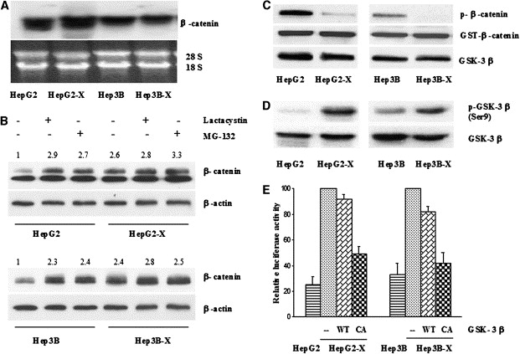
Figure 2.HBX Stabilizates β-Catenin through Inactivation of GSK-3β
(A) A Northern blot of total RNA showed comparable mRNA levels of β-catenin in HepG2, HepG2-X and Hep3B, Hep3B-X.
(B) Cells as indicated were treated with proteasome inhibitor Lactacystin (10 μM) or MG132 (20 μM). Cell lysates were blotted with anti-β-catenin antibody.
(C) Kinase activity of GSK-3β. GSK-3β was immunoprecipitated and incubated with GST-β-catenin as described in the Experimental Procedures. Reaction products were analyzed by Western blotting.
(D) Cell lysates as indicated were blotted with anti-p-GSK-3β (Ser9) and anti-GSK-3β antibody.
(E) Cells were transfected with Top or Fop plus wild-type or constitutively active GSK-3β as indicated, and then a Tcf-regulated reporter assay was performed to detect the transcriptional activity of β-catenin. The error bars represent standard deviation.

The Erk/p90RSK Pathway Is Required for HBX-Mediated Inactivation of GSK-3β
We next investigated which signal pathway is involved in HBX-mediated phosphorylation of GSK-3β at Ser9. It is known that three kinases, p90RSK, a downstream kinase of Erk, and AKT and PKC, that can be activated by HBX (Murakami, 2001) can phosphorylate GSK-3β at the Ser9 residue (Eldar-Finkelman, 2002). To delineate which kinase is responsible for phosphorylation of GSK-3β, we exploited specific inhibitors to block these kinases: Calphostin C to block PKC, LY294002 and Wortmannin to block the PI-3K/PKB pathway, and PD98059 to block the Erk/p90RSK pathway. A reporter assay showed that only PD98059 inhibited HBX-upregulated β-catenin transcriptional activity in a dose-dependent manner (Figure 3A), while other inhibitors did not (data not shown). Furthermore, the dominant-negative Erk also inhibited HBX-upregulated β-catenin transcriptional activity (Figure 3B). Consistently, PD98059 significantly inhibited the phosphorylation of GSK-3β at Ser9 and the protein level of β-catenin in HepG2-X and Hep3B-X cells (Figure 3C). Taken together, the results suggest that the HBX-activated Erk pathway plays a major role in the HBX-induced β-catenin upregulation. To determine whether p90RSK is required for the phosphorylation of GSK-3β at Ser9 by the HBX-activated Erk pathway, small interfering RNA (siRNA-RSK) was used to block p90RSK expression. We found that treatment of HBX transfectants with siRNA-RSK resulted in a reduced level of β-catenin and GSK-3β phosphorylation at Ser9 when compared with nonspecific siRNA treatment (Figure 3D), and siRNA-RSK also suppressed the HBX-upregulated transcriptional activity of β-catenin (Figure 3E). These results indicated that the Erk/p90RSK pathway is required for phosphorylation of GSK-3β at the Ser9 residue and upregulation of β-catenin by HBX.
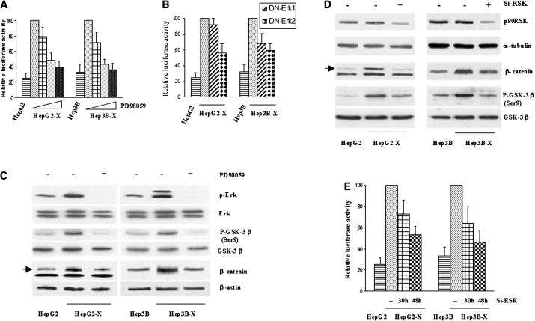
Figure 3.HBX Inactivates GSK-3β through the Erk/p90RSK Pathway
(A) Cells as indicated were transfected with Top or Fop and treated with increasing dose of MEK1/Erk inhibitor PD98059 (10, 20, and 50 μM), and then a Tcf-regulated reporter assay was performed to detect the transcriptional activity of β-catenin. The error bars represent standard deviation.
(B) Cells were transfected with Top or Fop plus DN-Erk1 or DN-Erk2 as indicated, and then a Tcf-regulated reporter assay was performed to detect the transcriptional activity of β-catenin. The error bars represent standard deviation.
(C) Cell lysates, treated or untreated with PD98059, were blotted with antibodies as indicated. The arrow marks the position of wt β-catenin. The p-Erk1 was not activated in HepG2-X cells, and accordingly, DN-Erk1 did not inhibit β-catenin activity in this cell (B).
(D) Cells as marked were transfected with siRNA-RSK or nonspecific siRNA as a negative control, and then cell lysates were blotted with antibodies as indicated.
(E) Cells were transfected with Top or Fop plus siRNA-RSK or nonspecific siRNA as a negative control, and then a Tcf-regulated reporter assay was performed to detect the transcriptional activity of β-catenin. The error bars represent standard deviation.

Erk Docks to GSK-3β at DEF Domain and Phosphorylates GSK-3β at the 43T Residue
p90RSK has been known to phosphorylate GSK-3β at Ser9 for quite some time (Stambolic and Woodgett, 1994); however, there is no evidence indicating direct association between these two molecules (Frodin and Gammeltoft, 1999). As an Erk downstream target, p90RSK is also known to interact directly with Erk (Frodin and Gammeltoft, 1999); however, it is not known whether there is direct interaction between Erk and GSK-3β. Interestingly, we identified a site (291FKFP) in the C terminus of GSK-3β that is similar with the consensus Erk-docking motif, FXFP, known as the DEF domain (Jacobs et al., 1999 and Lee et al., 2004). These motifs are highly conserved among different species (Figure 4A), suggesting that Erk may interact with GSK-3β. Taken together, this led us to hypothesize that Erk may serve as a scaffold to hold GSK-3β and p90RSK in a complex to facilitate GSK-3β phosphorylation by p90RSK. In support of this notion, a coimmunoprecipitation experiment demonstrated that Erk was associated with GSK-3β and p90RSK at the same time in all four cells (Figure 4B). Furthermore, the result of double immunoprecipitation clearly shows that the three proteins, Erk, GSK-3β, and p90RSK, are in the same complex (Figure S2). To validate the Erk docking site on GSK-3β, we mutated the potential docking site 291FKFP on a GSK-3β kinase-dead mutant (GST-GSK-3β KD) by substituting the phenylalanine residues Phe 291 and 293 with alanine (FKF to AKA) to produce GST-GSK-3β KD291/3A. A GST-GSK-3β pull-down assay demonstrated that GST-GSK-3β has an association with Erk and p90RSK (lane 1, Figure 4C), but disrupting the DEF domain of GSK-3β significantly reduces the association of GSK-3β with Erk and p90RSK (lane 2, Figure 4C). The results support the notion that Erk docks to GSK-3β at the DEF domain and bridges GSK-3β and p90RSK together, which may facilitate GSK-3β phosphorylation by p90RSK. As Erk interacts with GSK-3β, we then ask whether Erk may phosphorylate GSK-3β. To this end, we identified five putative Erk-phosphorylation motifs, 43TP, 275TP, 309TP, 324TP, and 330TP in GSK-3β. These motifs are highly conserved among different species. Mass spectrometry was used to identify phosphorylation sites of GSK-3β by Erk, and 43T was the only one found to be phosphorylated by Erk (Figure 4D). To further confirm phosphorylation of 43T, we constructed mutants of GSK-3β at 43T and generated antibody against the phosphorylation site of GSK-3β, Thr43, to examine whether Erk could phosphorylate GSK-3β in vivo. Mutation of GSK-3β 43T significantly inhibited the phosphorylation of GSK-3β by Erk (lane 3, Figures 4E and 4F) even though it still interacted with Erk (lane 3, Figure 4C). Moreover, the phosphorylation level of GSK-3β at Thr43 is significantly higher in the HepG2-X and IGF-1-treated HepG2 cells in which Erk is also highly phosphorylated compared to HepG2 cells (lanes 4 and 2 versus lane 3, Figure 4G), while Erk/MAPK inhibitor PD98059 can dramatically inhibit GSK-3β phosphorylation at Thr43 in the HepG2-X and IGF-1-treated HepG2 cells (lanes 5 and 1 versus lanes 4 and 2, Figure 4G). Furthermore, consistent with our hypothesis, mutating the Erk-docking motif (DEF domain) of GSK-3β, which impaired the association of GSK-3β with Erk (lane 2, Figure 4C), also significantly inhibited the phosphorylation of GSK-3β by Erk (lane 2, Figure 4E). These data demonstrate that Erk docks to GSK-3β at the DEF domain to bridge GSK-3β and p90RSK together and phosphorylates GSK-3β at the 43T residue.
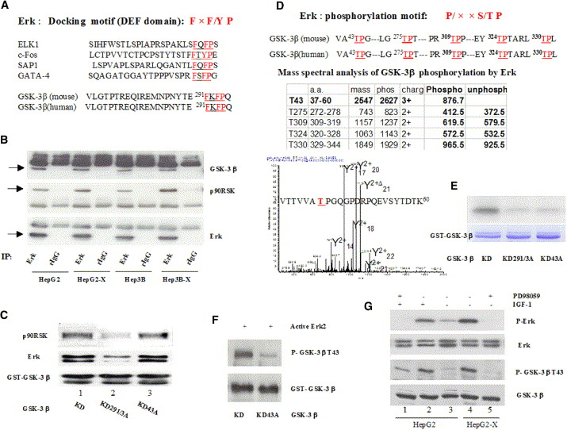
Figure 4.Erk Docks to GSK-3β at the DEF Domain and Phosphorylates GSK-3β at the 43T Residue
(A) Comparison of the amino acid sequences of the Erk-docking site (DEF domain) in GSK-3β with other known Erk substrates.
(B) Endogenous Erk was immunoprecipitated from cell lysates as indicated, and immunocomplexes were blotted with antibodies specific to GSK-3β, Erk, and p90RSK.
(C) GSK-3β interacts with Erk directly and with p90RSK indirectly though the DEF domain. Purified GST-GSK-3β proteins as indicated were mixed with Hep3B-X cell lysate and then pulled down with glutathione-sepharose 4B beads. Samples were subjected to immunoblot with anti-Erk, anti-p90RSK, and anti-GST (for detection of GST- GSK-3β) antibodies.
(D) Mass spectral analysis of GSK-3β phosphorylation by Erk. GSK-3β was phosphorylated at the 43T residue in vitro by Erk2.
(E) Mutant GST-GSK-3β protein as indicated was incubated with active Erk2, and the kinase assay was performed as described in the Experimental Procedures.
(F) Mutant GST-GSK-3β protein as indicated was incubated with active Erk2, and then samples were subjected to immunoblot with anti-p-GSK-3β (Thr43) and anti-GST (for detection of GST-GSK-3β) antibodies.
(G) Cell lysates of HepG2 and HepG2-X, treated with IGF-1 (40 ng/ml) or PD98058 (20 μM), were blotted with antibodies as indicated.

Erk Docking to GSK-3β and Phosphorylating GSK-3β Are Required for HBX-Mediated Inactivation of GSK-3β and Upregulation of β-Catenin
We next asked whether Erk docking to GSK-3β and phosphorylating GSK-3β have effects on the HBX-mediated inactivation of GSK-3β and upregulation of β-catenin. Mutation at either the docking motif (GSK-3β291/3A) or the phosphorylation site (GSK-3β43A), which prevents 43T phosphorylation, reduced HBX-mediated Ser9 phosphorylation of GSK-3β (Figure 5A), indicating that GSK-3β docking to Erk and phosphorylation at the 43T residue by Erk are required for HBX-induced inactivation of GSK-3β. Moreover, mutation of the 43T residue to aspartate (GSK-3β43D) retains Ser9 phosphorylation of GSK-3β (Figure 5A), suggesting that 43T phosphorylation serves as a priming site for Ser9 phosphorylation of GSK-3β. The two mutants, GSK-3β291/3A and GSK-3β43A, can cause significant ubiquitination of β-catenin as compared to wild-type GSK-3β and primed GSK-3β(GSK-3β43D) (lanes 3 and 5 versus lanes 1 and 7, Figure 5B), which is independent of Erk inhibitor PD98059 (lanes 4 and 6 versus lanes 3 and 5, Figure 5B); however, ubiquitination of β-catenin caused by wild-type GSK-3β is increased by treatment with Erk inhibitor in the Hep3B-X cells (lane 2 versus lane 1, Figure 5B). The results suggest that GSK-3β docking to Erk and phosphorylation by Erk are required for inhibition of β-catenin ubiquitination and therefore likely for β-catenin stabilization. Consistent with this notion, the two mutants, GSK-3β291/3A and GSK-3β43A, decreased the HBX-upregulated protein level of β-catenin and its downstream target c-myc (Figure 5C) and also suppressed HBX-upregulated β-catenin transcriptional activity showed by a Tcf-regulated reporter assay as compared to wild-type GSK-3β and primed GSK-3β(GSK-3β43D) (Figure 5D). Taken together, these results indicate that both GSK-3β291/3A and GSK-3β43A mutants function as constitutively active GSK-3β to downregulate β-catenin, and suggest that GSK-3β association with Erk and phosphorylation at the 43T residue by Erk are required for the subsequent phosphorylation at Ser9 to inactivate GSK-3β and upregulate β-catenin.

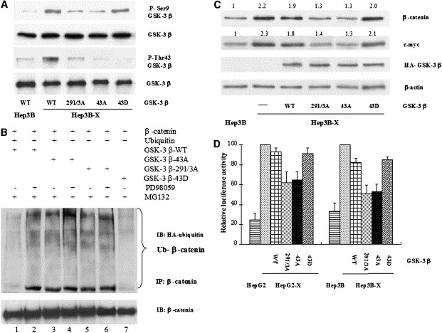
Figure 5.Erk Docking to GSK-3β and Phosphorylation of GSK-3β Are Required for HBX-Mediated Inactivation of GSK-3β and Upregulation of β-Catenin
(A) GSK-3β mutants as indicated were transfected to Hep3B-X cells, and then GSK-3β was immunoprecipitated and the complexes were subjected to immunoblot with specific p-Ser9 and p-Thr43 GSK-3β antibodies.
(B) Ubiquitination analysis. Hep3B-X cells were transfected with HA-ubiquitin, β-catenin, and GSK-3β-wt, 43A, 43D, or 291/3A, then treated with PD98059 and MG132 as indicated. β-catenin was immunoprecipitated and blotted with anti-HA-ubiquitin.
(C) Hep3B-X cells were transfected with GSK-3β-wt, 43A, 43D, or 291/3A, then harvested for immunoblot as indicated.
(D) Cells were transfected with Top or Fop plus GSK-3β-wt, 43A, 43D, or 291/3A as indicated, and then a Tcf-regulated reporter assay was performed to detect the transcriptional activity of β-catenin. The error bars represent standard deviation.

HER2 and IGF-1 in Breast Cancer, Like HBX in Hepatoma, Can Upregulate β-Catenin through Inactivation of GSK-3β by the Erk Pathway
To investigate whether a similar relationship between Erk and GSK-3β observed in HCC can also be found in other cancer types, we searched for cell lines that express a high level of both p-Erk and β-catenin. Out of five breast cancer cell lines we screened, MDA-MB-435 and MCF-7/H18 (HER2-transfected MCF-7) were identified to have relatively high levels of p-Erk, β-catenin, and β-catenin transcription activity (Figure 6A). Immunofluorescence staining also indicated that expression of β-catenin was increased and translocated to the nucleus in the MCF-7/H18 cell lines as compared to the parental MCF-7 (Figure 6B). Treatment with Erk inhibitor PD98059 (Figure 6C), or transfection by GSK-3β mutants 291/3A or 43A (Figure 6D), resulted in inhibition of transcriptional activity of β-catenin in these breast cancer cells. Moreover, in breast cancer cell line MDA-MB-231 and hepatoma cell line Hep3B, growth factor IGF-1 can lead to β-catenin upregulation and phosphorylation of Erk and GSK-3β(Ser9). Once treated with Erk inhibitor PD98059 or siRNA-Erk, phosphorylated Erk was reduced in the IGF-1-treated cells, and concurrently, downregulation of β-catenin and inhibition of GSK-3β(Ser9) phosphorylation were observed (Figure 6E), suggesting that IGF-1-induced β-catenin upregulation is mediated by the Erk/GSK-3β pathway. To further examine whether this relationship identified in the cell lines can also be observed in human tumor tissues, we compared the levels of phosphorylated GSK-3β and β-catenin in six phosphorylated Erk-negative and six phosphorylated Erk-positive human breast tumors. To prevent interference by Akt, which is also able to phosphorylate GSK-3β at Ser9, the above 12 tumor tissues were preselected to be negative for phosphorylated Akt by IHC (Hu et al., 2004). Strongly supporting the notion, GSK-3β was highly phosphorylated at Ser9 in six of six phosphorylated Erk-positive breast tumors, and β-catenin accumulated in both the cytoplasm and nucleus in these tumor samples, while p-GSK-3β(Ser9) and nuclear β-catenin were not detected in all six p-Erk negative specimens (Figure 6F). In addition, we also examined a number of human primary tumor specimens by IHC using a tumor tissue array. Among 12 individual tumor specimens, the same functional relationship between p-Erk, p-GSK-3β, and accumulation of β-catenin was found in two tumor entities, stomach carcinoma and renal cell carcinoma (Figure S3), suggesting that the Erk/GSK-3β/β-catenin relationship may be a general phenomenon frequently activated in multiple human tumors.

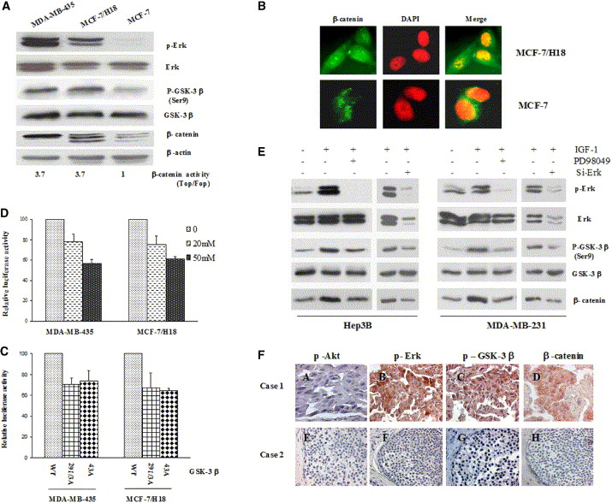
Figure 6.HER2 and IGF-1 Upregulate β-Catenin through Inactivation of GSK-3β by the Erk Pathway in Breast Cancer
(A) Lysates of breast cancer cell lines were blotted with antibody as indicated, and a Tcf-regulated reporter assay was performed as in Figure 1E.
(B) An immunofluorescence assay was performed on cell lines as indicated to measure the expression and cellular localization of β-catenin.
(C) Cells as marked were transfected with Top or Fop, then treated with PD98059. A Tcf-regulated reporter assay was performed as in Figure 1E. The error bars represent standard deviation.
(D) Cells were transfected with Top or Fop plus GSK-3β mutants as indicated, and then a Tcf-regulated reporter assay was performed as in Figure 1B. The error bars represent standard deviation.
(E) MDA-MB-231 and Hep3B cells were pretreated with PD98059 (20 μM) or siRNA-Erk1+2 before stimulation with IGF-1 (40 ng/ml). The expression of β-catenin and the status of GSK-3β and Erk were examined by Western blotting.
(F) Tissue sections from p-Akt-negative breast cancer (FA–FH) were stained with specific antibody against p-Erk (FB and FF), p-Ser9 of GSK-3β (FC and FG), and β-catenin (FD and FH).

Discussion
HCC is one of the most prevalent human malignancies and a leading cause of death in many countries, mainly in Asia and Africa, and it is clearly linked to viral infection. Individuals who are chronic HBV carriers have a greater than 100-fold increased relative risk of developing HCC (Arbuthnot and Kew, 2001). Effects of HBX on transcriptional activation, signal transduction, and DNA repair implicate it in the etiology of HBV-associated HCC. It is well known that oncogenic virus often provides some clues about how cancer might develop. For instance, when mutation in APC, Axin, and β-catenin cannot elucidate β-catenin stabilization, the latency-associated nuclear antigen protein of Kaposi sarcoma-associated herpesvirus relocalizes GSK-3β, which leads to cytoplasmic depletion of GSK-3β and accumulation of β-catenin (Fujimuro et al., 2003), and the large T antigen of the human polyomavirus JC virus can activate β-catenin through directly binding it (Gan and Khalili, 2004). Mutations in APC, Axin, and β-catenin represent only 50% of the upregulation of β-catenin in hepatoma, raising an interesting possibility for a relationship between HBX and β-catenin. In this study, we found that accumulation of β-catenin in human HCC samples was significantly correlated with HBX expression, and importantly, we identified a mechanism to stabilize β-catenin involving GSK-3β phosphorylation and inactivation by the HBX-activated Erk/RSK pathway, which will help us further understand the roles of HBX in the HBV-related HCC.
Upregulation of β-catenin occurred in a variety of cancers, such as colorectal, breast, and ovarian cancers (Lin et al., 2000, Morin et al., 1997 and Rask et al., 2003), and its ability to induce neoplastic transformation of normal cells proves that β-catenin is a bona fide oncogene (Kolligs et al., 1999 and Orford et al., 1999). Inhibition of GSK-3β is essential for the stabilization of β-catenin. GSK-3β inactivation can be achieved by two primary mechanisms. One mechanism is Wnt-dependent inhibition (Cook et al., 1996, Itoh et al., 2000, Li et al., 1999 and Ruel et al., 1999); the other mechanism is phosphorylation of GSK-3β at the Ser9 residue (Cohen and Frame, 2001). GSK-3β inhibition can be caused by a number of growth factors including IGF-1, EGF, PDGF, FGF-2, HGF, TGF-β, TNF-α, etc. (Cheon et al., 2004, Desbois-Mouthon et al., 2001, Holnthoner et al., 2002 and Papkoff and Aikawa, 1998), and one virus protein, the latent membrane protein 2A of Epstein-Barr virus (Morrison et al., 2003), has been reported to increase β-catenin stabilization through Ser9 phosphorylation of GSK-3β. However, in certain cell types inhibition of GSK-3β via Ser9 phosphorylation is not sufficient to induce β-catenin accumulation (Ding et al., 2000 and Yuan et al., 1999), suggesting that the consequences of changed GSK-3β activity on β-catenin stabilization are cell type dependent. For instance, reduced GSK-3β activity caused by insulin stimulation leads to β-catenin accumulation in HepG2 cells and cardiomyocytes (Desbois-Mouthon et al., 2001 and Haq et al., 2003), but not in human embryonic kidney 293 cells (Ding et al., 2000). In the current study, we observed that in hepatoma cell lines HepG2 and Hep3B, inactivation of GSK-3β via Ser9 phosphorylation is involved in HBX-mediated β-catenin stabilization. Another important finding is identification of a mechanism to elucidate accurately how the Erk/p90RSK pathway phosphorylates and inactivates GSK-3β. Like HBX in hepatoma, HER2 and IGF-1 in breast cancer cells can also upregulate β-catenin through inactivation of GSK-3β via Ser9 phosphorylation by the Erk/RSK pathway. In addition, we noticed that in WI-38 fibroblast cells, TGF-β-mediated upregulation of β-catenin also required Erk phosphorylation and Ser9 phosphorylation of GSK-3β (Figure S4). Thus, the functional Erk/GSK-3β/β-catenin relationship may be a general phenomenon in multiple biological systems.
Our results, together with previous findings, provide a plausible mechanism (Figure 7) for how MAPK/Erk stabilizes β-catenin to facilitate cell proliferation. Growth factor/receptor or HBX activate the Erk pathway. On one hand, Erk phosphorylates and activates p90RSK, and on the other hand, Erk serves as an adaptor and priming kinase through binding to the DEF domain of GSK-3β and phosphorylating GSK-3β at the 43T residue, to facilitate phosphorylation of GSK-3β by p90RSK on Ser9, which leads to the inactivation of GSK-3β. Thus, β-catenin is stabilized in the cytoplasm and translocated to the nucleus, and then it interacts with Tcf/Lef and upregulates its downstream targets such as cyclin D1 and c-myc, which will facilitate cell proliferation. In conclusion, the mechanism, namely Erk-primed inactivation of GSK-3β, directly links HBX or growth factor/receptor and the β-catenin signal pathway together and may be involved in the development of multiple human cancers.

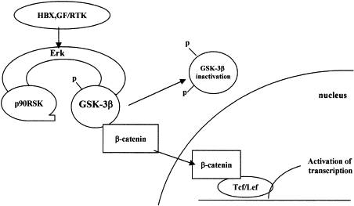
Figure 7.Model for Erk Association with and Priming of GSK-3β for Its Inactivation Resulting in Upregulation of β-Catenin

Experimental Procedures
Constructs and Reagents
pCGN-GSK-3β and pGEX-GSK-3β KD were provided by A. Kikuchi and J. Woodgett, respectively. Using the QuickChange Multisite-Directed Mutagenesis Kit (Stratagene, La Jolla, CA), all GSK-3β mutants based on the above two GSK-3β constructs were generated according to the manufacturer’s protocol, and all mutations were verified by sequencing. Dominant-negative Erk1/2 and constitutively active GSK-3β (S9A GSK-3β) were provided by P.E. Shaw and M.J. Birnhaum, respectively.
MEK1 inhibitor PD98059 and PI-3 kinase inhibitor LY294002 were purchased from Cell Signaling Technology. PKC inhibitor Calphostin C, PI-3 kinase inhibitor Wotmannin, proteasome inhibitor Lactacystin, and MG132, IGF-1, and TGF-β were purchased from Sigma.

Cell Culture, Tcf Reporter Assay, and FACS Analysis
Cells were cultured in DMEM/F12 supplemented with 10% fetal bovine serum. HBX-expressing cells were grown under the same conditions, except that 500 μg/ml G418 was added to the culture medium. The Tcf-regulated reporter assay was performed as described (Deng et al., 2002). For cell proliferation assays, FACS analyses were used to measure the cell cycle. Cells were transfected with vector control, dominant-negative Tcf4, and siRNA-β-catenin plus GFP (ratio 5:1), respectively, for 48 hr. The procedure for FACS analysis was performed according to protocol. Briefly, cells were trypsinized, washed in PBS, treated with 1% formaldehyde for 1 hr, and fixed in 70% ice-cold ethanol overnight. Then, fixed cells were incubated with 1 ml PI solution (Sigma; 50 μg/ml PBS) plus 25 μg/ml of RNase for 30 min at 37°C in the dark until measurement, and cell sorting was performed according to the expression of GFP. These experiments were repeated twice.

Immunoblotting, Immunoprecipitation, and GST Pull-Down Assay
Immunoblotting (IB) and immunoprecipitation (IP) were done essentially as described, with the following antibodies: GSK-3β, β-catenin, p90RSK (BD Transduction Labs, San Diego, CA), phospho (Ser9)-GSK-3β (Calbiochem, San Diego, CA, and Cell Signaling Technology, Beverly, MA), phosphothreonine-proline antibody (Abcam, Cambridge, MA), phospho-Akt (Ser473), phospho-β-catenin (Ser33/37/Thr41) (Cell Signaling Technology), phospho-Erk, Erk (Upstate Biotechnology, Lake Placid, NY), c-myc (BD Pharmingen, San Diego, CA), mouse anti-HBX (Chemicon, Temecula, CA), and rabbit anti-HBX serum (kindly provided by B.L. Slagle). Specific antibody against the phosphorylation site of GSK-3β Thr43 was generated with a synthetic phosphorylated peptide KVTTVVApTPGQGPD corresponding to amino acid residues 36–39 of GSK-3β by GeneTex, Inc. (San Antonio, TX).
For GST pull-down assays, GST-GSK-3β protein (10 μg) as indicated was incubated at 4°C with Hep3B-X extract (5 mg) overnight, and then GST-tagged proteins were recovered by incubating the reaction at 4°C for 3 hr with 20 μl glutathione-Sepharose 4B beads. The bead pellet was washed three times with 1 ml buffer (20 mM Tris-HCl [pH 7.5], 150 mM NaCl, 10% glycerol, 1% Triton X-100, and 2 mM EDTA). Boiled samples were then subjected to 12% SDS-PAGE.

In Vitro Kinase Assay and Phosphorylation Analysis
Purified GST-GSK-3β protein as indicated incubated with active Erk2 (Upstate Biotechnology), and purified GST-β-catenin protein incubated with GST-GSK-3β protein or immunopreciptated GSK-3β from cell lysate as indicated in the presence of 50 mM ATP in a kinase buffer containing 5μCi [γ-32P]ATP for 30 min at 30°C. Reaction products were resolved by SDS-PAGE, and 32P-labeled proteins were visualized by autoradiography.
Mass spectral analysis of the in vitro phosphorylated GSK-3β by Erk2 was performed as described (Kalkum et al., 2003).

Immunohistochemical and Immunofluorescent Staining
Immunohistochemical (IHC) staining of all human cancer and normal tissue samples, and immunofluorescent (IF) staining of hepatoma and breast cancer cell lines were performed as described (Deng et al., 2002 and Zhou et al., 2001). Fifty-three surgically resected human HCC specimens were collected from Union Hospital, Tongji Medical College, Wuhan, P.R. China. A test slide (Cat# IMH-343) for tumor tissue array was purchased from IMGENEX.

Northern Blot
Total RNA was isolated using TRIzol (Invitrogen, Carlsbad, CA). RNA (20 μg) was separated and transferred to a membrane, then probed using β-catenin DNA labeled by random oligonucleotide priming.

Small Interfering RNA Transfection
Small interfering RNA (siRNA) duplex oligos (Dharmacon) targeting p90RSK mRNA (RSK1, RSK2 and RSK3 consensus region, 5′-AAG GCC ACA CUG AAA GUU CG -3′) or a nonspecific duplex oligo as a negative control (5′-AAC AGU CGC GUU UGC GAC UGG-3′) (1.6 μg/35 mm plate or 12.8 μg/100 mm plate) was transfected by Lipofectamine 2000 (Invitrogen) to perform the reporter assay, or by electroporation using the Nuclofector 1 System (Amaxa) to perform the Western blot.
Small interfering RNA (siRNA) duplex oligo targeting β-catenin mRNA, and pSUPER-derived expression vectors for small interfering RNA (siRNAs) against Erk1 and Erk2 were performed as described (Deng et al., 2002 and Chatterjee et al., 2004).

Acknowledgments
We thank M.A. Feitelson and S.L. Doong for providing HepG2-X and Hep3B-X cells, respectively, and J.R. Woodgett, A. Kikuchi, P.E. Shaw, M.J. Birnhaum, B.L. Slagle, and J. Deng for reagents. This work was partially supported by U.S. NIH grants PO1 (CA099031 M-C.H), RO1 (CA109311 and CA58880 M-C.H), and CCSG (CA 16672), the Kadoorie Charitable Foundation, and the National Breast Cancer Foundation.

References
Aberle et al., 1997 H. Aberle, A. Bauer, J. Stappert, A. Kispert and R. Kemler, β-catenin is a target for the ubiquitin-proteasome pathway, EMBO J. 16 (1997), pp. 3797–3804.
Amit et al., 2002 S. Amit, A. Hatzubai, Y. Birman, J.S. Andersen, E. Ben-Shushan, M. Mann, Y. Ben-Neriah and I. Alkalay, Axin-mediated CKI phosphorylation of beta-catenin at Ser 45: a molecular switch for the Wnt pathway, Genes Dev. 16 (2002), pp. 1066–1076.
Arbuthnot and Kew, 2001 P. Arbuthnot and M. Kew, Hepatitis B virus and hepatocellular carcinoma, Int. J. Exp. Pathol. 82 (2001), pp. 77–100.
Benn and Schneider, 1994 J. Benn and R.J. Schneider, Hepatitis B virus HBx protein activates Ras-GTP complex formation and establishes a Ras, Raf, MAP kinase signaling cascade, Proc. Natl. Acad. Sci. USA 91 (1994), pp. 10350–10354.
Benn et al., 1996 J. Benn, F. Su, M. Doria and R.J. Schneider, Hepatitis B virus HBx protein induces transcription factor AP-1 by activation of extracellular signal-regulated and c-Jun N-terminal mitogen-activated protein kinases, J. Virol. 70 (1996), pp. 4978–4985.
Chatterjee et al., 2004 M. Chatterjee, T. Stuhmer, P. Herrmann, K. Bommert, B. Dorken and R.C. Bargou, Combined disruption of both the MEK/ERK and the IL-6R/STAT3 pathways is required to induce apoptosis of multiple myeloma cells in the presence of bone marrow stromal cells, Blood 104 (2004), pp. 3712–3721.
Cheon et al., 2004 S.S. Cheon, P. Nadesan, R. Poon and B.A. Alman, Growth factors regulate beta-catenin-mediated TCF-dependent transcriptional activation in fibroblasts during the proliferative phase of wound healing, Exp. Cell Res. 293 (2004), pp. 267–274.
Cohen and Frame, 2001 P. Cohen and S. Frame, The renaissance of GSK3, Nat. Rev. Mol. Cell Biol. 2 (2001), pp. 769–776.
Cook et al., 1996 D. Cook, M.J. Fry, K. Hughes, R. Sumathipala, J.R. Woodgett and T.C. Dale, Wingless inactivates glycogen synthase kinase-3 via an intracellular signalling pathway which involves a protein kinase C, EMBO J. 15 (1996), pp. 4526–4536.
Cromlish, 1996 J.A. Cromlish, Hepatitis B virus-induced hepatocellular carcinoma: possible roles for HBx, Trends Microbiol. 4 (1996), pp. 270–274.
de La Coste et al., 1998 A. de La Coste, B. Romagnolo, P. Billuart, C.A. Renard, M.A. Buendia, O. Soubrane, M. Fabre, J. Chelly, C. Beldjord, A. Kahn and C. Perret, Somatic mutations of the beta-catenin gene are frequent in mouse and human hepatocellular carcinomas, Proc. Natl. Acad. Sci. USA 95 (1998), pp. 8847–8851.
Deng et al., 2002 J. Deng, S.A. Miller, H.Y. Wang, W. Xia, Y. Wen, B.P. Zhou, Y. Li, S.Y. Lin and M.C. Hung, β-catenin interacts with and inhibits NF-kappa B in human colon and breast cancer, Cancer Cell 2 (2002), pp. 323–334.
Desbois-Mouthon et al., 2001 C. Desbois-Mouthon, A. Cadoret, M.J. Blivet-Van Eggelpoel, F. Bertrand, G. Cherqui, C. Perret and J. Capeau, Insulin and IGF-1 stimulate the beta-catenin pathway through two signalling cascades involving GSK-3beta inhibition and Ras activation, Oncogene 20 (2001), pp. 252–259.
Ding et al., 2000 V.W. Ding, R.H. Chen and F. McCormick, Differential regulation of glycogen synthase kinase 3beta by insulin and Wnt signaling, J. Biol. Chem. 275 (2000), pp. 32475–32481.
Eldar-Finkelman, 2002 H. Eldar-Finkelman, Glycogen synthase kinase 3: an emerging therapeutic target, Trends Mol. Med. 8 (2002), pp. 126–132.
Feitelson et al., 1993 M.A. Feitelson, M. Zhu, L.X. Duan and W.T. London, Hepatitis B x antigen and p53 are associated in vitro and in liver tissues from patients with primary hepatocellular carcinoma, Oncogene 8 (1993), pp. 1109–1117.
Frodin and Gammeltoft, 1999 M. Frodin and S. Gammeltoft, Role and regulation of 90 kDa ribosomal S6 kinase (RSK) in signal transduction, Mol. Cell. Endocrinol. 151 (1999), pp. 65–77.
Fujimuro et al., 2003 M. Fujimuro, F.Y. Wu, C. ApRhys, H. Kajumbula, D.B. Young, G.S. Hayward and S.D. Hayward, A novel viral mechanism for dysregulation of beta-catenin in Kaposi’s sarcoma-associated herpesvirus latency, Nat. Med. 9 (2003), pp. 300–306.
Gan and Khalili, 2004 D.D. Gan and K. Khalili, Interaction between JCV large T-antigen and beta-catenin, Oncogene 23 (2004), pp. 483–490.
Haq et al., 2003 S. Haq, A. Michael, M. Andreucci, K. Bhattacharya, P. Dotto, B. Walters, J. Woodgett, H. Kilter and T. Force, Stabilization of beta-catenin by a Wnt-independent mechanism regulates cardiomyocyte growth, Proc. Natl. Acad. Sci. USA 100 (2003), pp. 4610–4615.
He et al., 1998 T.C. He, A.B. Sparks, C. Rago, H. Hermeking, L. Zawel, L.T. da Costa, P.J. Morin, B. Vogelstein and K.W. Kinzler, Identification of c-MYC as a target of the APC pathway, Science 281 (1998), pp. 1509–1512.
Holnthoner et al., 2002 W. Holnthoner, M. Pillinger, M. Groger, K. Wolff, A.W. Ashton, C. Albanese, P. Neumeister, R.G. Pestell and P. Petzelbauer, Fibroblast growth factor-2 induces Lef/Tcf-dependent transcription in human endothelial cells, J. Biol. Chem. 277 (2002), pp. 45847–45853.
Hu et al., 2004 M.C. Hu, D.F. Lee, W. Xia, L.S. Golfman, F. Ou-Yang, J.Y. Yang, Y. Zou, S. Bao, N. Hanada and H. Saso et al., IkappaB kinase promotes tumorigenesis through inhibition of forkhead FOXO3a, Cell 117 (2004), pp. 225–237.
Itoh et al., 2000 K. Itoh, A. Antipova, M.J. Ratcliffe and S. Sokol, Interaction of dishevelled and Xenopus axin-related protein is required for wnt signal transduction, Mol. Cell. Biol. 20 (2000), pp. 2228–2238.
Jacobs et al., 1999 D. Jacobs, D. Glossip, H. Xing, A.J. Muslin and K. Kornfeld, Multiple docking sites on substrate proteins form a modular system that mediates recognition by ERK MAP kinase, Genes Dev. 13 (1999), pp. 163–175.
Kalkum et al., 2003 M. Kalkum, G.J. Lyon and B.T. Chait, Detection of secreted peptides by using hypothesis-driven multistage mass spectrometry, Proc. Natl. Acad. Sci. USA 100 (2003), pp. 2795–2800.
Kim et al., 1991 C.M. Kim, K. Koike, I. Saito, T. Miyamura and G. Jay, HBx gene of hepatitis B virus induces liver cancer in transgenic mice, Nature 351 (1991), pp. 317–320.
Kitagawa et al., 1999 M. Kitagawa, S. Hatakeyama, M. Shirane, M. Matsumoto, N. Ishida, K. Hattori, I. Nakamichi, A. Kikuchi and K. Nakayama, An F-box protein, FWD1, mediates ubiquitin-dependent proteolysis of beta-catenin, EMBO J. 18 (1999), pp. 2401–2410.
Kolligs et al., 1999 F.T. Kolligs, G. Hu, C.V. Dang and E.R. Fearon, Neoplastic transformation of RK3E by mutant beta-catenin requires deregulation of Tcf/Lef transcription but not activation of c-myc expression, Mol. Cell. Biol. 19 (1999), pp. 5696–5706.
Lee et al., 2004 T. Lee, A.N. Hoofnagle, Y. Kabuyama, J. Stroud, X. Min, E.J. Goldsmith, L. Chen, K.A. Resing and N.G. Ahn, Docking motif interactions in MAP kinases revealed by hydrogen exchange mass spectrometry, Mol. Cell 14 (2004), pp. 43–55. Article | PDF (974 K) | View Record in Scopus | Cited By in Scopus (102)
Lee and Yun, 1998 Y.H. Lee and Y. Yun, HBx protein of hepatitis B virus activates Jak1-STAT signaling, J. Biol. Chem. 273 (1998), pp. 25510–25515.
Li et al., 1999 L. Li, H. Yuan, C.D. Weaver, J. Mao, G.H. Farr 3rd, D.J. Sussman, J. Jonkers, D. Kimelman and D. Wu, Axin and Frat1 interact with dvl and GSK, bridging Dvl to GSK in Wnt-mediated regulation of LEF-1, EMBO J. 18 (1999), pp. 4233–4240.
Lin et al., 2000 S.Y. Lin, W. Xia, J.C. Wang, K.Y. Kwong, B. Spohn, Y. Wen, R.G. Pestell and M.C. Hung, β-catenin, a novel prognostic marker for breast cancer: its roles in cyclin D1 expression and cancer progression, Proc. Natl. Acad. Sci. USA 97 (2000), pp. 4262–4266.
Liu et al., 2002 C. Liu, Y. Li, M. Semenov, C. Han, G.H. Baeg, Y. Tan, Z. Zhang, X. Lin and X. He, Control of beta-catenin phosphorylation/degradation by a dual-kinase mechanism, Cell 108 (2002), pp. 837–847.
Maguire et al., 1991 H.F. Maguire, J.P. Hoeffler and A. Siddiqui, HBV X protein alters the DNA binding specificity of CREB and ATF-2 by protein-protein interactions, Science 252 (1991), pp. 842–844.
Morin et al., 1997 P.J. Morin, A.B. Sparks, V. Korinek, N. Barker, H. Clevers, B. Vogelstein and K.W. Kinzler, Activation of beta-catenin-Tcf signaling in colon cancer by mutations in beta-catenin or APC, Science 275 (1997), pp. 1787–1790.
Morrison et al., 2003 J.A. Morrison, A.J. Klingelhutz and N. Raab-Traub, Epstein-Barr virus latent membrane protein 2A activates beta-catenin signaling in epithelial cells, J. Virol. 77 (2003), pp. 12276–12284.
Murakami, 2001 S. Murakami, Hepatitis B virus X protein: a multifunctional viral regulator, J. Gastroenterol. 36 (2001), pp. 651–660.
Nelson and Nusse, 2004 W.J. Nelson and R. Nusse, Convergence of Wnt, beta-catenin, and cadherin pathways, Science 303 (2004), pp. 1483–1487.
Orford et al., 1999 K. Orford, C.C. Orford and S.W. Byers, Exogenous expression of beta-catenin regulates contact inhibition, anchorage-independent growth, anoikis, and radiation-induced cell cycle arrest, J. Cell Biol. 146 (1999), pp. 855–868.
Papkoff and Aikawa, 1998 J. Papkoff and M. Aikawa, WNT-1 and HGF regulate GSK3 beta activity and beta-catenin signaling in mammary epithelial cells, Biochem. Biophys. Res. Commun. 247 (1998), pp. 851–858.
Peifer and Polakis, 2000 M. Peifer and P. Polakis, Wnt signaling in oncogenesis and embryogenesis–a look outside the nucleus, Science 287 (2000), pp. 1606–1609.
Playford et al., 2000 M.P. Playford, D. Bicknell, W.F. Bodmer and V.M. Macaulay, Insulin-like growth factor 1 regulates the location, stability, and transcriptional activity of beta-catenin, Proc. Natl. Acad. Sci. USA 97 (2000), pp. 12103–12108.
Qadri et al., 1995 I. Qadri, H.F. Maguire and A. Siddiqui, Hepatitis B virus transactivator protein X interacts with the TATA-binding protein, Proc. Natl. Acad. Sci. USA 92 (1995), pp. 1003–1007.
Rask et al., 2003 K. Rask, A. Nilsson, M. Brannstrom, P. Carlsson, P. Hellberg, P.O. Janson, L. Hedin and K. Sundfeldt, Wnt-signalling pathway in ovarian epithelial tumours: increased expression of beta-catenin and GSK3beta, Br. J. Cancer 89 (2003), pp. 1298–1304.
Ruel et al., 1999 L. Ruel, V. Stambolic, A. Ali, A.S. Manoukian and J.R. Woodgett, Regulation of the protein kinase activity of Shaggy(Zeste-white3) by components of the wingless pathway in Drosophila cells and embryos, J. Biol. Chem. 274 (1999), pp. 21790–21796.
Satoh et al., 2000 S. Satoh, Y. Daigo, Y. Furukawa, T. Kato, N. Miwa, T. Nishiwaki, T. Kawasoe, H. Ishiguro, M. Fujita and T. Tokino et al., AXIN1 mutations in hepatocellular carcinomas, and growth suppression in cancer cells by virus-mediated transfer of AXIN1, Nat. Genet. 24 (2000), pp. 245–250.
Shih et al., 2000 W.L. Shih, M.L. Kuo, S.E. Chuang, A.L. Cheng and S.L. Doong, Hepatitis B virus X protein inhibits transforming growth factor-beta -induced apoptosis through the activation of phosphatidylinositol 3-kinase pathway, J. Biol. Chem. 275 (2000), pp. 25858–25864.
Stambolic and Woodgett, 1994 V. Stambolic and J.R. Woodgett, Mitogen inactivation of glycogen synthase kinase-3 beta in intact cells via serine 9 phosphorylation, Biochem. J. 303 (1994), pp. 701–704.
Su and Schneider, 1996 F. Su and R.J. Schneider, Hepatitis B virus HBx protein activates transcription factor NF-kappaB by acting on multiple cytoplasmic inhibitors of rel-related proteins, J. Virol. 70 (1996), pp. 4558–4566.
Suzuki et al., 2002 T. Suzuki, H. Yano, Y. Nakashima, O. Nakashima and M. Kojiro, β-catenin expression in hepatocellular carcinoma: a possible participation of beta-catenin in the dedifferentiation process, J. Gastroenterol. Hepatol. 17 (2002), pp. 994–1000.
Taniguchi et al., 2002 K. Taniguchi, L.R. Roberts, I.N. Aderca, X. Dong, C. Qian, L.M. Murphy, D.M. Nagorney, L.J. Burgart, P.C. Roche and D.I. Smith et al., Mutational spectrum of beta-catenin, AXIN1, and AXIN2 in hepatocellular carcinomas and hepatoblastomas, Oncogene 21 (2002), pp. 4863–4871.
Terradillos et al., 1997 O. Terradillos, O. Billet, C.A. Renard, R. Levy, T. Molina, P. Briand and M.A. Buendia, The hepatitis B virus X gene potentiates c-myc-induced liver oncogenesis in transgenic mice, Oncogene 14 (1997), pp. 395–404.
Tetsu and McCormick, 1999 O. Tetsu and F. McCormick, β-catenin regulates expression of cyclin D1 in colon carcinoma cells, Nature 398 (1999), pp. 422–426.
Wong et al., 2001 C.M. Wong, S.T. Fan and I.O. Ng, β-Catenin mutation and overexpression in hepatocellular carcinoma: clinicopathologic and prognostic significance, Cancer 92 (2001), pp. 136–145.
Yuan et al., 1999 H. Yuan, J. Mao, L. Li and D. Wu, Suppression of glycogen synthase kinase activity is not sufficient for leukemia enhancer factor-1 activation, J. Biol. Chem. 274 (1999), pp. 30419–30423.
Zhou et al., 2001 B.P. Zhou, Y. Liao, W. Xia, B. Spohn, M.H. Lee and M.C. Hung, Cytoplasmic localization of p21Cip1/WAF1 by Akt-induced phosphorylation in HER-2/neu-overexpressing cells, Nat. Cell Biol. 3 (2001), pp. 245–252.

